Introduction:
Session 1: Grace

Session 2: Connecting to Creation

Session 3: Connecting to Community

Session 4:
Final Commentary: Reflection on my learning I connect
----------------------------------------------------------------------------------------------------------------------------------------------------------------------------------------
Session 1: Grace – the Cross

This Psalm keeps resonating in my heart and mind:
“When I consider Your heavens, the work of Your fingers, The moon and the stars, which You have ordained, What is man that You are mindful of him, And the son of man that You visit him?” (Psalms 8:3, 4 NKJV)
What is man that You are mindful of him? What am I, Lord, that you are mindful of me? My problems, my worries, my hopes, and my dreams?

Where do I come from? The whirpool galaxy - I live in the Darling of the universe division of this galaxy.
https://scientistsforjesus.wordpress.com/2013/11/26/our-universe-indescribable/
ans you would have to travel 186,000 miles a second for 100,000 years to reach one end to the other.
https://www.google.com/search?q=eye+universe++louie+giglio&rlz=1C1GCEB_enAU991AU991&tbm=isch&sxsrf=ALiCzsbk-BcVnWwKwxVMT_cJDSur2MSSqQ:1666421180880&source=lnms&sa=X&ved=2ahUKEwiQ_qDUnvP6AhUS7TgGHZGuC9cQ_AUoAXoECAoQAw&biw=1280&bih=577&dpr=1.5
Indescribable | Pastor Louie Giglio (youtube.com)
In the centre of our subdivision where the earth is, is this in the middle of a dark whirlpool
Eye of the universe – the little blue dot in the center is earth
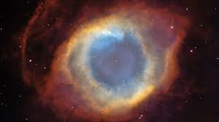

Session 1 (Grace/Spirituality):
1. What are important aspects of spirituality from a Lutheran perspective?
2. In what ways might the concept of grace shape Lutheran education communities?
3. In what ways might the concept of grace inform the understanding of my role and my contribution?
4. What questions or issues does the concept raise for me and how can I explore my questions?

John Donne: The Cross
THE CROSS.
by John Donne
SINCE Christ embraced the cross itself, dare I
His image, th' image of His cross, deny ?
Would I have profit by the sacrifice,
And dare the chosen altar to despise ?
It bore all other sins, but is it fit
That it should bear the sin of scorning it ?
Who from the picture would avert his eye,
How would he fly his pains, who there did die ?
From me no pulpit, nor misgrounded law,
Nor scandal taken, shall this cross withdraw,
It shall not, for it cannot ; for the loss
Of this cross were to me another cross.
Better were worse, for no affliction,
No cross is so extreme, as to have none.
Who can blot out the cross, with th' instrument
Of God dew'd on me in the Sacrament ?
Who can deny me power, and liberty
To stretch mine arms, and mine own cross to be ?
Swim, and at every stroke thou art thy cross ;
The mast and yard make one, where seas do toss ;
Look down, thou spiest out crosses in small things ;
Look up, thou seest birds raised on crossed wings ;
All the globe's frame, and spheres, is nothing else
But the meridians crossing parallels.
Material crosses then, good physic be,
But yet spiritual have chief dignity.
These for extracted chemic medicine serve,
And cure much better, and as well preserve.
Then are you your own physic, or need none,
When still'd or purged by tribulation ;
For when that cross ungrudged unto you sticks,
Then are you to yourself a crucifix.
As perchance carvers do not faces make,
But that away, which hid them there, do take ;
Let crosses, so, take what hid Christ in thee,
And be His image, or not His, but He.
But, as oft alchemists do coiners prove,
So may a self-despising get self-love ;
And then, as worst surfeits of best meats be,
So is pride, issued from humility,
For 'tis no child, but monster ; therefore cross
Your joy in crosses, else, 'tis double loss.
And cross thy senses, else both they and thou
Must perish soon, and to destruction bow.
For if the eye seek good objects, and will take
No cross from bad, we cannot 'scape a snake.
So with harsh, hard, sour, stinking ; cross the rest ;
Make them indifferent ; call, nothing best.
But most the eye needs crossing, that can roam,
And move ; to th' others th' objects must come home.
And cross thy heart ; for that in man alone
Pants downwards, and hath palpitation.
Cross those dejections, when it downward tends,
And when it to forbidden heights pretends.
And as the brain through bony walls doth vent
By sutures, which a cross's form present,
So when thy brain works, ere thou utter it,
Cross and correct concupiscence of wit.
Be covetous of crosses; let none fall ;
Cross no man else, but cross thyself in all.
Then doth the cross of Christ work faithfully
Within our hearts, when we love harmlessly
That cross's pictures much, and with more care
That cross's children, which our crosses are.

PLC Grace based Lutheran theology

Session 2: Connecting to Creation

darling of the universe – louie giglio
Reflect: Creation Theology
What has brought you here?
What challenges are there?
What makes it different.
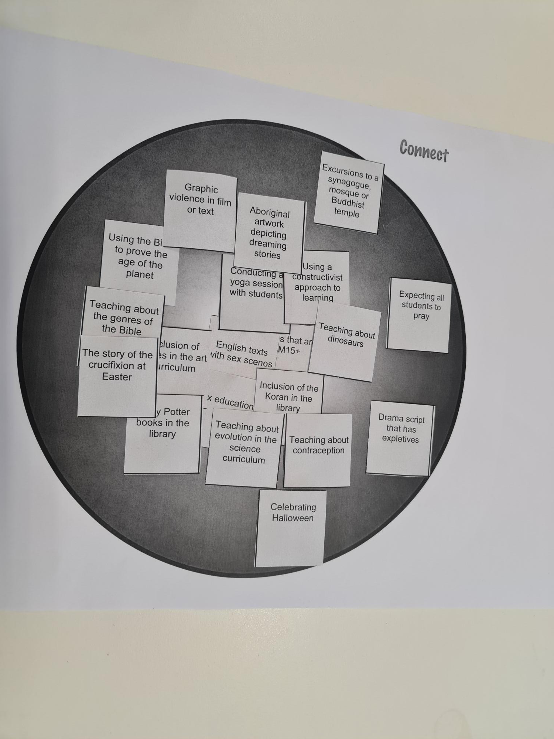
What we teach?
AC – what is permissible
"Everything is permissible for me"--but not everything is beneficial. "Everything is permissible for me"--but I will not be mastered by anything. "Food for the stomach and the stomach for food"--but God will destroy them both. The body is not meant for sexual immorality, but for the Lord, and the Lord for the body.

Bible Gateway 1 Corinthians 6 :: NIV

Why we teach it?
Students and what they need to learn vs teachers and what we want to teach.
What would Jesus think of me in my classroom? What would me dad think?
How effective is my teaching? To what effect do I impact the Kingdom?
Am I making a good Godly difference and how would I know this?

Look at the BIBLE Project?
Gen 1
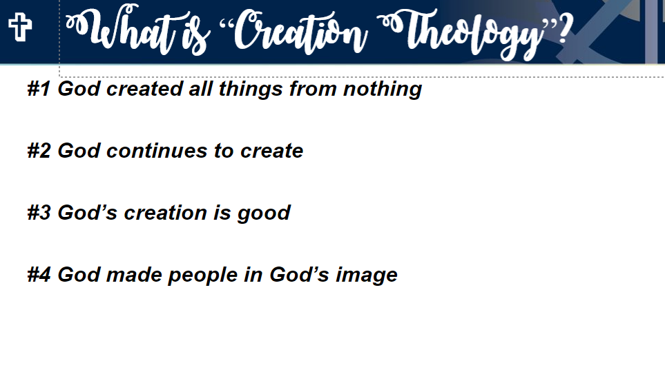
#1 God created all things from nothing
#2 God continues to create
#3 God’s creation is good
#4 God made people in God’s image
#5 God creates people as unique individuals
#6 God invites people to be co-creators
#7 God promises to restore the brokenness of creation through Jesus

As God is real to me – I need to share that reality with others. The world is distracting, and families are keen for us to be respectful of their children and what they believe in this space. It is easy to get mainstream information but many families choose PLC because they trust that we will entrust their children into the care of God and Christianity.
I believe that God has created me together with all that exists. God has given me and still preserves my body and soul: eyes, ears, and all limbs and senses; reason and all mental faculties. In addition, God daily and abundantly provides shoes and clothing, food and drink, house and farm, spouse and children, fields, livestock, and all property – along with all the necessities and nourishment for this body and life.
Martin Luther
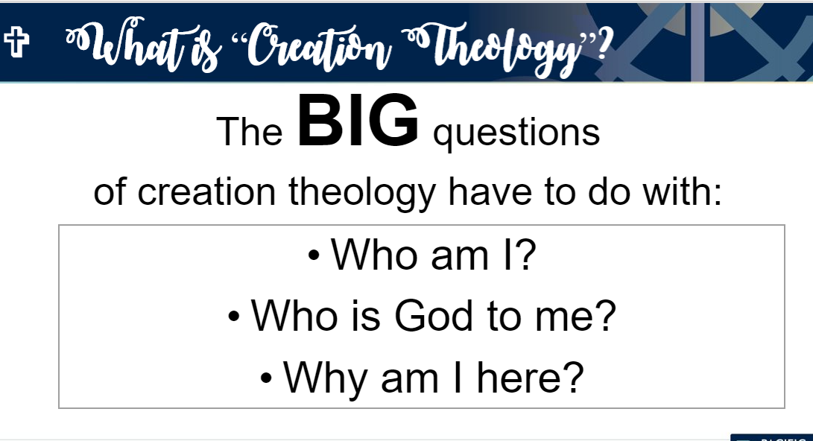
Often people send their children to a faith school because they want teachers

. How does creation theology inform the why and how of Lutheran education?
2. How does creation theology shape an aspect of your work with students?
3. What questions or issues does the concept raise for me and how can I explore my questions?

Session 3: lanolin in body Louie giglio

https://padlet.com/mhauser1/s6u5rcu68iqou36x/wish/2237065270
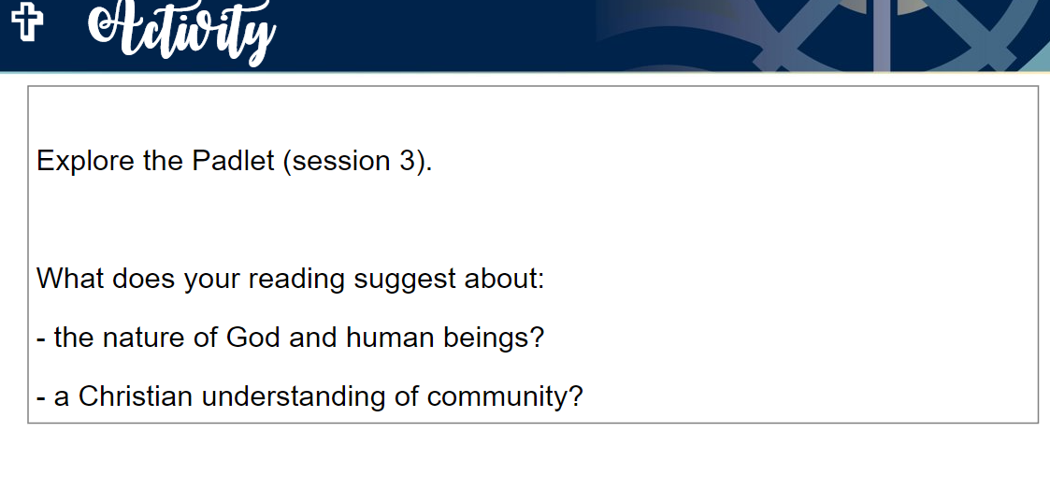
. How does creation theology inform the why and how of Lutheran education?
2. How does creation theology shape an aspect of your work with students?
3. What questions or issues does the concept raise for me and how can I explore my questions?

PLC Connect Session 3 - Community (padlet.com)

He said, “My passion in life is to spread the Gospel, through the tool of excellence in education. I believe education needs to be rigorous and equip students with the tools to be all God has called them to be. There can be no compromise in the quality of education a Christian school provides and the pathways it provides for every student. We want to see the next generation of students, stepping into adulthood, choosing Jesus Christ as Lord and Saviour of their lives.”
1. Why does Lutheran Education value community?
2. In what ways has the learning about community relationships informed your understanding of your role and contribution?
3. What questions or issues does the concept raise for me and how can I explore my questions?

Malcolm Bartsch
PLC Connect Session 3 - Community (padlet.com)

c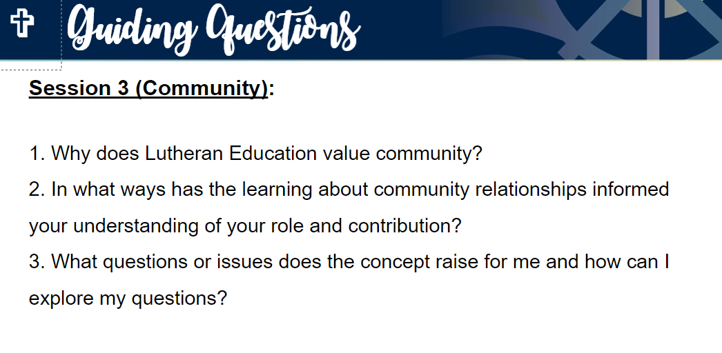

“Lutheran schools and early childhood services are communities that recognise that God has intentionally created each person and that each person is uniquely gifted to live in relationship with God and others.”
What links can you make between this statement and your definition of a flourishing community?

the nature of God and human beings?
- a Christian understanding of community?

Session 4 (Our foundation) The Bible
Growing deep: our foundation
Lutheran schools and early childhood services are communities of hope, nurtured by the promises of God’s word, love and forgiveness which empower staff and students to embrace the future with confidence.

Enduring understanding
God’s word inspires and guides Lutheran education communities.
Guiding questions for workshops, ePortfolio critical reflection
- How can we know about God?
- How does God’s word form and inform Lutheran education communities and my role?
- What are the most significant aspects of Lutheran theology for Lutheran education?
- What questions or issues does the concept raise for me and how can I explore my questions?

